- Setup a virtual machine using Ubuntu image.
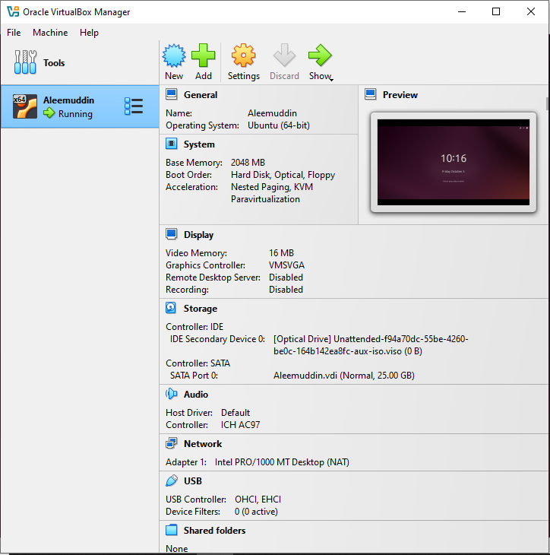
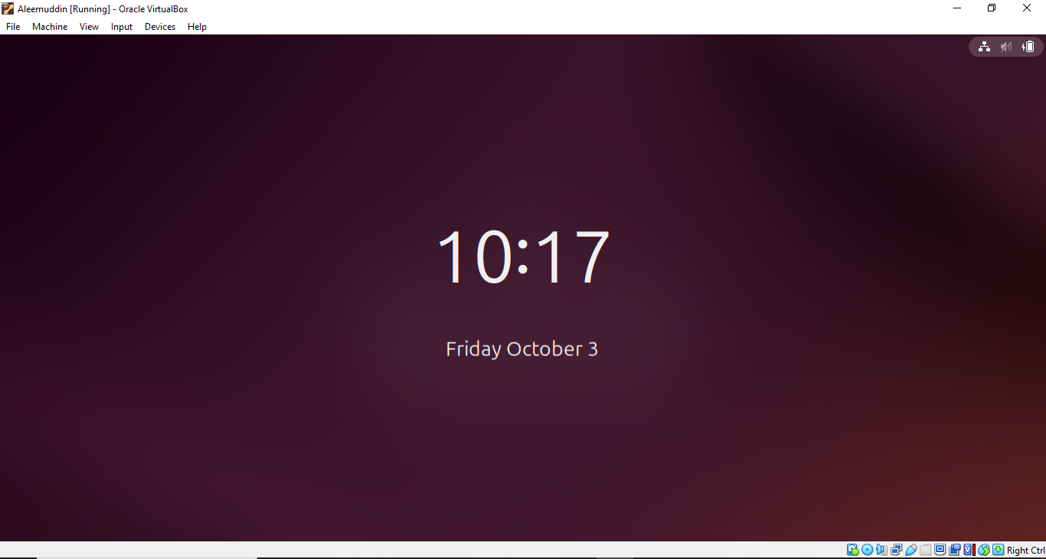
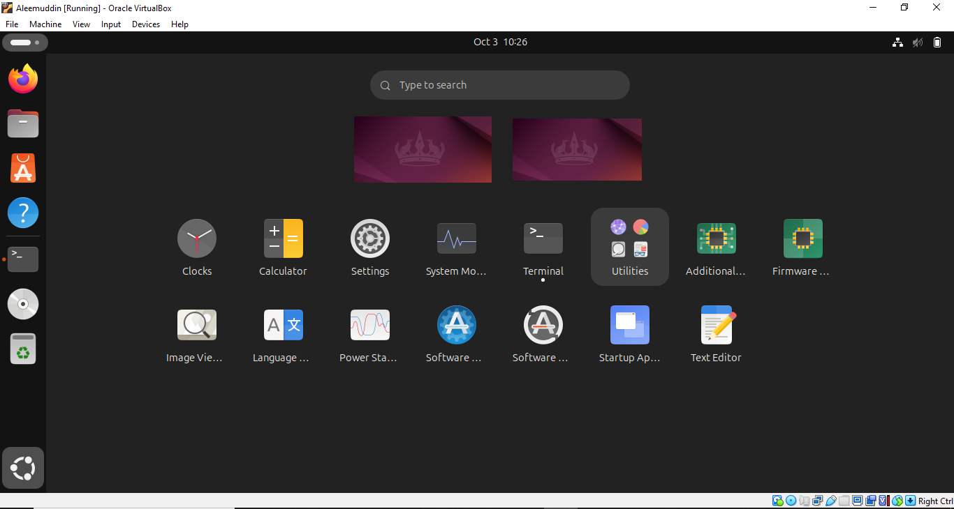

- Install docker on ec2.
Launch one ec2 instance
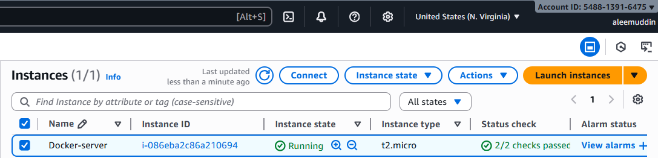
Install docker in the same ec2
Yum install docker -y
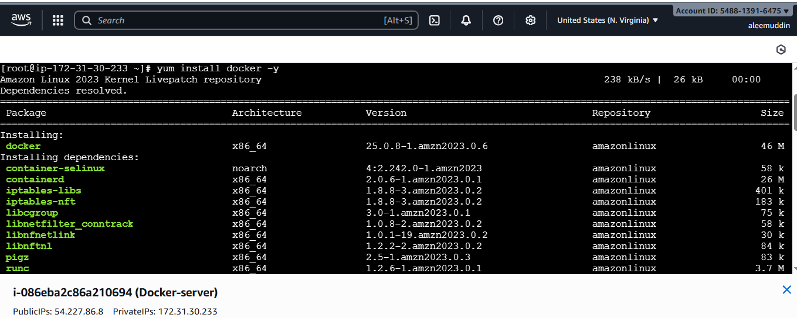
Sudo systemctl start docker
Sudo systemctl enable docker
Sudo system status docker

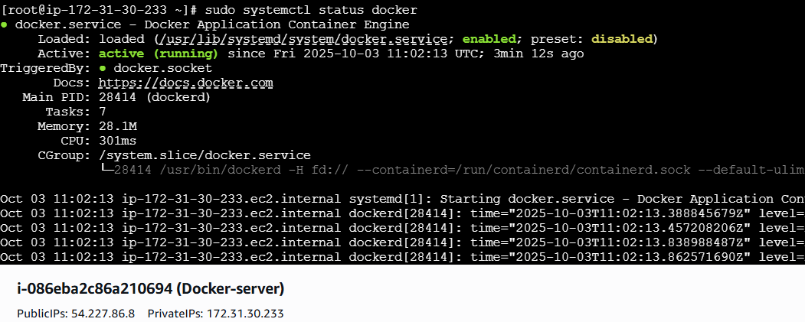
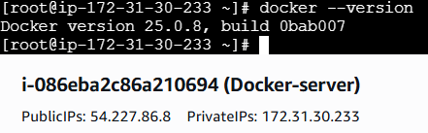
- Pull 5 docker images. (nginx, Apache tomcat, ubuntu, Jenkins, SonarQube)
Docker pull <image name>
Nginx image
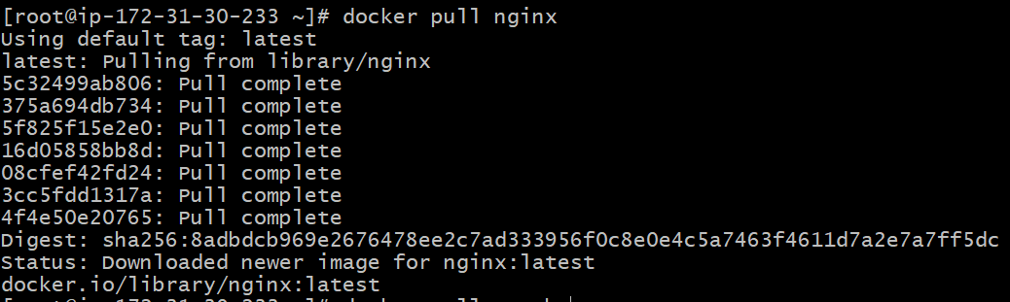
Tomcat image
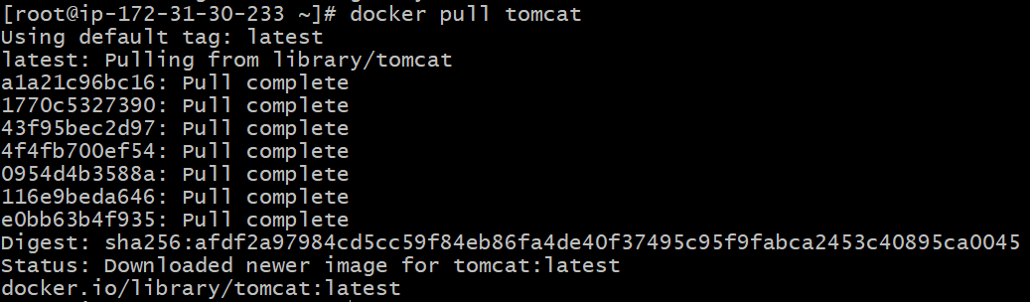
Ubuntu image
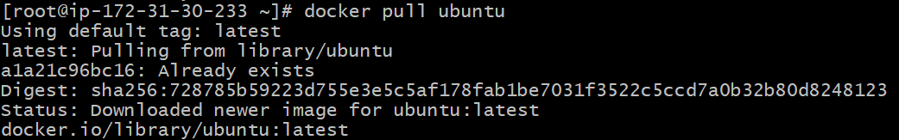
Jenkins image
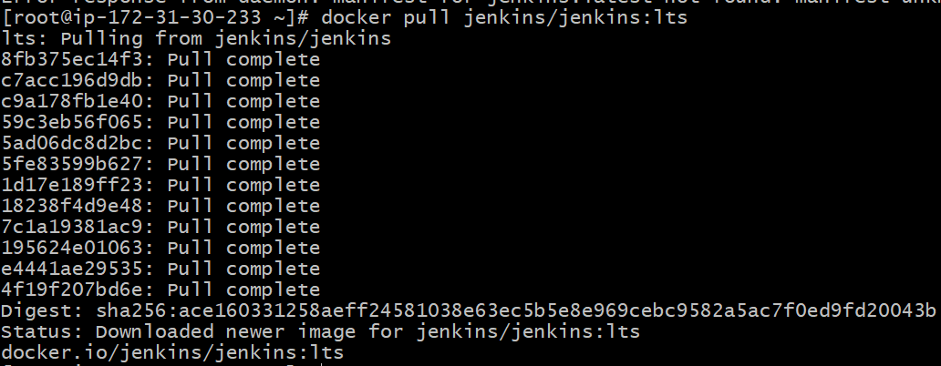
Sonarqube image
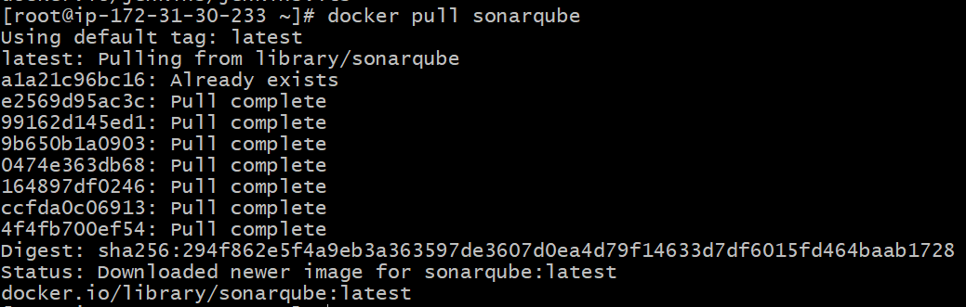
Total docker images available in the machine
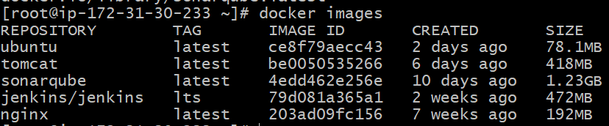
- Run nginx container and expose on port 81.
Docker container running with nginx image
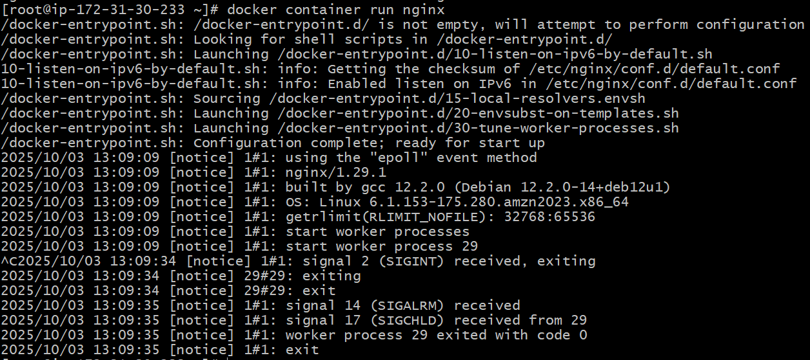
Can see port no-80 in the below image
Changing to port no-81
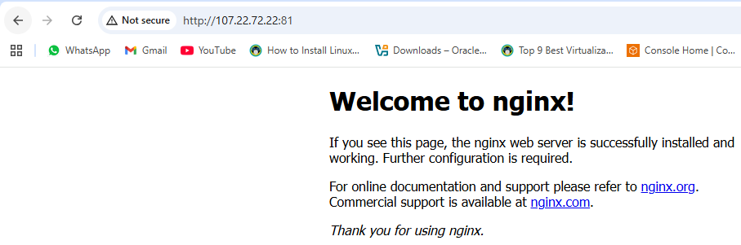
- Delete the Apache tomcat image from local.
List of images pulled
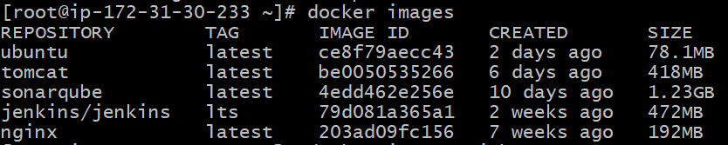
Tomcat image deleted
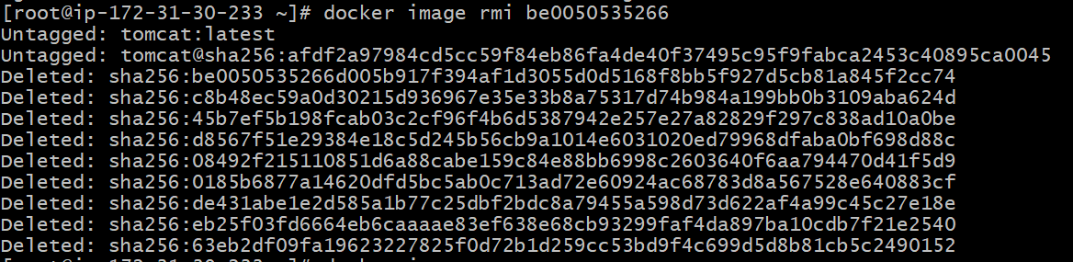
After deleted tomcat list of images available
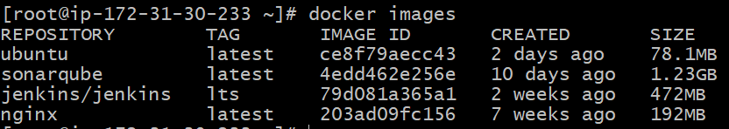
- Inspect the Jenkins image, SonarQube image.
Inspect Jenkins container
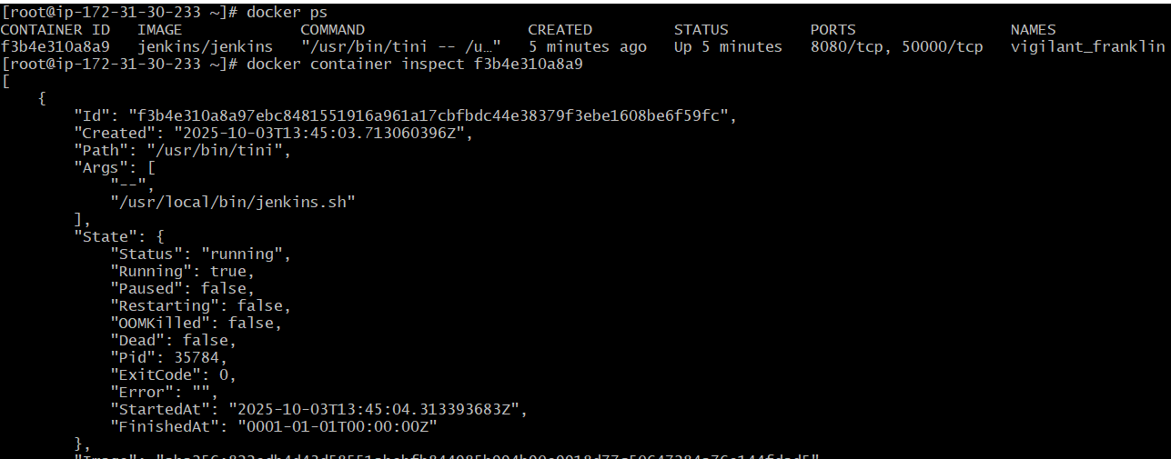
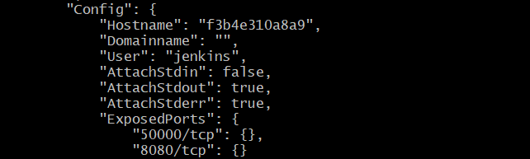
Inspect sonarqube container
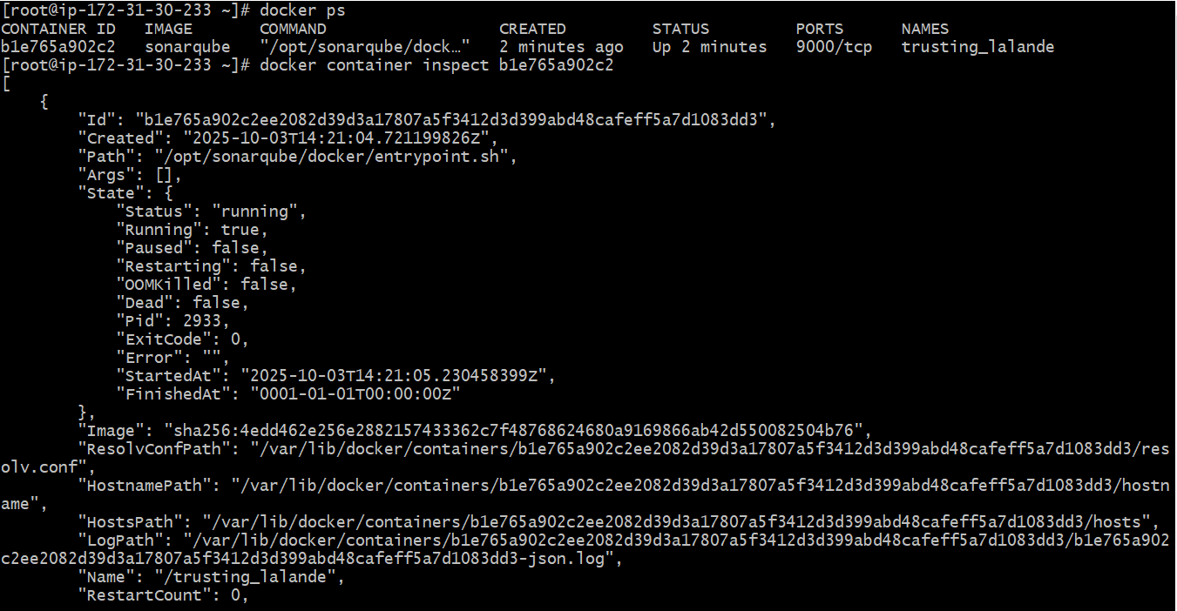

- Run Jenkins container and run one sample job.
